**Accessibility Testing and Fixing Project**

**and Presentation of Website**

# Table of Content

**Table of Content 1**

**Table, Figures, and Links: 3**

**1. Introduction 4**

1.1 Audit Summary: 4

1.2 Tools used 5

1.3 Methodology 5

**2. Audit findings of Website 6**

2.1 Issues 6

2.2 Issues Description 8

Table 2.1.1: Issues found in website 8

2.2 Screenshot of issues 9

Figure 2.2.1: Screenshot of WAVE result of home page 9

Figure 2.2.2: Screenshot of AXE result of home page 9

Figure 2.2.3: Screenshot of Lighthouse result of home page 9

Figure 2.2.4: Screenshot of WAVE result of license page 10

Figure 2.2.5: Screenshot of AXE result of license page 10

Figure 2.2.6: Screenshot of Lighthouse result of license page 10

Figure 2.2.7: Screenshot of WAVE result of registration page 11

Figure 2.2.8: Screenshot of AXE result of registration page 11

Figure 2.2.9: Screenshot of Lighthouse result of registration page 11

Figure 2.2.10: Screenshot of WAVE result of appointment page 12

Figure 2.2.11: Screenshot of AXE result of appointment page 12

Figure 2.2.12: Screenshot of Lighthouse result of appointment page 12

Figure 2.2.13: Screenshot of WAVE result of contact page 13

Figure 2.2.14: Screenshot of AXE result of contact page 13

Figure 2.2.15: Screenshot of Lighthouse result of contact page 13

**3. Validation 14**

3.1 Empty alt attribute 14

Figure 3.1.1: Screenshot of empty alt attribute issue 14

3.2 Low contrast text 14

Figure 3.1.2: Screenshot of low contrast text issue 14

3.3 Vague link text 15

Figure 3.1.3: Screenshot of vague link text issue 15

3.4 Missing lang attribute 15

Figure 3.1.4: Screenshot of missing lang attribute issue 15

3.5 Incorrect heading order 15

Figure 3.1.5: Screenshot of incorrect heading order issue 16

3.6 Table missing <th> cells 16

Figure 3.1.6: Screenshot of missing table header attribute issue 16

3.7 Redundant links 17

Figure 3.1.7: Screenshot of redundant link issue 17

3.8 Missing <label> attribute 17

Figure 3.1.8: Screenshot of missing <label> attribute issue 17

**4. Remediation 18**

4.1 Empty alt attribute 18

Figure 4.1.1: Screenshot of fixed empty alt attribute issue 18

Link 4.1.2: Go to view fixed empty alt attribute validated by NVDA in video at drive 18

4.2 Low contrast text 18

Figure 4.2.1: Screenshot of fixed low contrast issue 18

4.3 Missing lang attribute 19

Figure 4.3.1: Screenshot of fixed lang attribute issue 19

4.4 Table missing <th> cells 19

Link 4.4.1: Go to view fixed table header validated by NVDA in video at drive 19

4.5 Missing <label> attribute 19

Figure 4.5.1: Screenshot of fixed missing label attribute issue 19

**5. Client Report 20**

5.1 Audit Summary 20

5.2 Issues Identified 20

5.3 Remediation Actions 22

5.4 Compliance Outcome: 24

**6. Presentation 25**

# 

# 

# Table, Figures, and Links:

Table 2.1.1: Issues found in PDF file 8

Figure 2.2.1: Screenshot of WAVE result of home page 9

Figure 2.2.2: Screenshot of AXE result of home page 9

Figure 2.2.3: Screenshot of Lighthouse result of home page 9

Figure 2.2.4: Screenshot of WAVE result of license page 10

Figure 2.2.5: Screenshot of AXE result of license page 10

Figure 2.2.6: Screenshot of Lighthouse result of license page 10

Figure 2.2.7: Screenshot of WAVE result of registration page 11

Figure 2.2.8: Screenshot of AXE result of registration page 11

Figure 2.2.9: Screenshot of Lighthouse result of registration page 11

Figure 2.2.10: Screenshot of WAVE result of appointment page 12

Figure 2.2.11: Screenshot of AXE result of appointment page 12

Figure 2.2.12: Screenshot of Lighthouse result of appointment page 12

Figure 2.2.13: Screenshot of WAVE result of contact page 13

Figure 2.2.14: Screenshot of AXE result of contact page 13

Figure 2.2.15: Screenshot of Lighthouse result of contact page 13

Figure 3.1.1: Screenshot of empty alt attribute issue 14

Figure 3.1.2: Screenshot of low contrast text issue 14

Figure 3.1.3: Screenshot of vague link text issue 15

Figure 3.1.4: Screenshot of missing lang attribute issue 15

Figure 3.1.5: Screenshot of incorrect heading order issue 16

Figure 3.1.6: Screenshot of missing table header attribute issue 16

Figure 3.1.7: Screenshot of redundant link issue 17

Figure 3.1.8: Screenshot of missing <label> attribute issue 17

Figure 4.1.1: Screenshot of fixed empty alt attribute issue 18

Link 4.1.2: Go to view fixed empty alt attribute validated by NVDA in video at drive 18

Figure 4.2.1: Screenshot of fixed low contrast issue 18

Figure 4.3.1: Screenshot of fixed lang attribute issue 19

Link 4.4.1: Go to view fixed table header validated by NVDA in video at drive 19

Figure 4.5.1: Screenshot of fixed missing label attribute issue 19

# 

# 

# 

# Introduction

Sample Website Developed Date: 5 October, 2025

Audit Date: 6 October, 2025

Website " Sample DMV Website": [Go to github for code](https://github.com/ak-nksha/dmv-gov-website)

Accessibility ensures that digital content and online services are usable by everyone, including people with disabilities such as visual, auditory, motor, or cognitive impairments. An accessible website allows users to perceive, understand, navigate, and interact with web content effectively, regardless of their abilities or assistive technologies used.

This accessibility audit was conducted to evaluate the “Sample DMV Website” for compliance with WCAG 2.1 Level AA and Section 508 standards.

* **WCAG (Web Content Accessibility Guidelines) 2.1 Level AA** provides internationally recognized guidelines ensuring that web content is perceivable, operable, understandable, and robust (POUR) for all users.
* **Section 508 of the Rehabilitation Act** is a U.S. federal standard requiring that all digital and electronic information be accessible to people with disabilities.

The purpose of this audit was to identify barriers that may prevent inclusive access, such as missing alternative text, poor color contrast, unclear headings, or inaccessible forms. The audit findings, remediation steps, and validation results demonstrate efforts to create a web environment that meets accessibility best practices and supports equal user experience for all.

## 1.1 Audit Summary:

The website was evaluated across five pages: **Home**, **License**, **Registration**, **Appointment**, and **Contact**.

Multiple accessibility issues were detected during automated and manual testing, including missing alternative text, low color contrast, missing language attributes, incorrect heading hierarchy, and missing form labels.

Remediation focused on improving structure, readability, and assistive technology compatibility through semantic HTML, proper labeling, and color contrast adjustments. After fixes were applied, the site was re-evaluated using automated tools,NVDA, Keyboard- only navigation, achieving partial compliance with WCAG 2.1 Level AA.

## 1.2 Tools used

**1.2.1 WAVE Evaluation Tool:**  
 It is used to detect accessibility issues such as missing alt text, low contrast, missing language attributes, and structural errors across webpages.

**1.2.2 AXE DevTools**:  
 It is used to perform detailed accessibility scanning to confirm WAVE findings and identify code-level errors like ARIA misuse, landmark issues, and heading inconsistencies.

**1.2.3 Lighthouse**:  
 It provides an overall accessibility score and analyses best practices for accessibility insights.

**1.2.4 NVDA Screen Reader**:  
 It is used to test how screen reader users experience content — ensuring proper heading order, link descriptions, and label accessibility.

**1.2.5 Keyboard-Only Navigation:**  
 It is used to verify that all interactive elements (headings, links, buttons, and form inputs) were reachable, operable, and visually focused using only the keyboard.

## 1.3 Methodology

**i. Automated Analysis:**  
 Initial scans using WAVE, axe DevTools, and Lighthouse to identify basic accessibility violations.

**ii. Manual Review:**  
 Inspected HTML code structure and tested content visually for color contrast, heading order, and ARIA role accuracy.

**iii. Assistive Technology Testing:** Used NVDA and keyboard-only navigation to validate real user experience for screen reader and non-mouse users.

**iv. Remediation & Validation:** Implemented fixes such as adding alt text, defining language, restructuring headings, and improving form labels. The website was re-tested to confirm issue resolution and compliance improvements.

# Audit findings of Website

## 2.1 Issues

Following are the accessibility issues found in 5 pages of the website:

* Home page:

From WAVE accessibility tool:

* + Empty alt attribute
  + Low contrast
  + Vague link text
  + Missing lang attribute

From AXE dev tool:

* + Missing lang attribute

From AXE dev tool:

* + Missing lang attribute
* License page:

From WAVE accessibility tool:

* + Incorrect heading order
  + Table missing <th> cells
  + Empty alt attribute

From AXE dev tool:

* + Incorrect heading order

From AXE dev tool:

* + Incorrect heading order
* Registration page:

From WAVE accessibility tool:

* + Improper table header
  + Redundant links

From AXE dev tool:

* + No issues found

From AXE dev tool:

* + No issues found
* Appointment page:

From WAVE accessibility tool:

* + Lang attribute
  + Missing <label> attribute

From AXE dev tool:

* + Lang attribute

From AXE dev tool:

* + Lang attribute
* Contact page:
  + No issues were found in the page

## 2.2 Issues Description

Following are the accessibility issues found with WCAG reference, user impact, and suggested fix:

### Table 2.1.1: Issues found in website

| S.N | Issue | WCAG Reference | User Impact | Suggested Fix |
| --- | --- | --- | --- | --- |
| 1 | Empty alt text | WCAG 1.1.1 Non-text Content (A) | Screen reader users miss image meaning; critical info may be lost | Add descriptive alt text to all meaningful images |
| 2 | Low contrast | WCAG 1.4.3 Contrast (Minimum) (AA) | Text becomes unreadable for low-vision users; fails basic legibility | Ensure proper contrast ratio |
| 3 | Vague link text | WCAG 2.4.4 Link Purpose (In Context) (A) | Users don’t know where links go; screen readers repeat “click here” | Use specific, descriptive link text |
| 4 | Missing lang attribute | WCAG 3.1.1 Language of Page (A) | Screen readers use wrong pronunciation; entire page may be misread | Add lang="en" (or appropriate language) to <html> |
| 5 | Incorrect heading order | WCAG 2.4.6 Headings and Labels (AA) | Navigation breaks; users can’t skim or jump by section | Use sequential heading levels (H1 → H2 → H3…) |
| 6 | Table missing <th> cells | WCAG 1.3.1 Info and Relationships (A) | Data relationships are lost; screen readers read cells without context | Use <th> for headers with proper scope attributes |
| 7 | Redundant links | WCAG 2.4.4 Link Purpose (In Context) (A) | Repetition confuses users; screen readers waste time on duplicate links | Consolidate or hide duplicate links from assistive tech |
| 8 | Missing <label> attribute | WCAG 3.3.2 Labels or Instructions (A) | Form fields are inaccessible; users don’t know what to enter | Add <label> for every input field |

## 

## 2.2 Screenshot of issues

### 

### Figure 2.2.1: Screenshot of WAVE result of home page

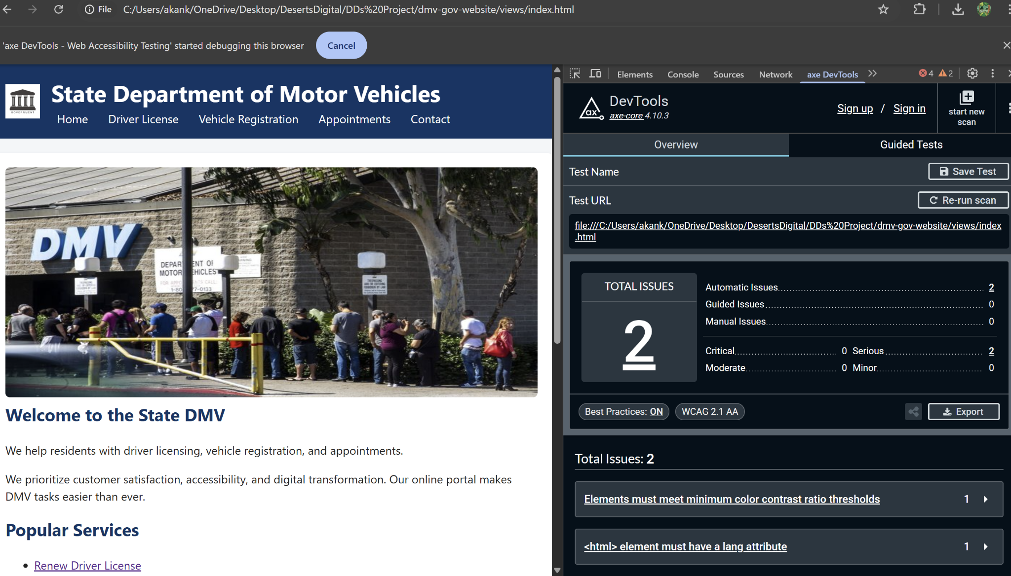

### Figure 2.2.2: Screenshot of AXE result of home page

### 

### Figure 2.2.3: Screenshot of Lighthouse result of home page

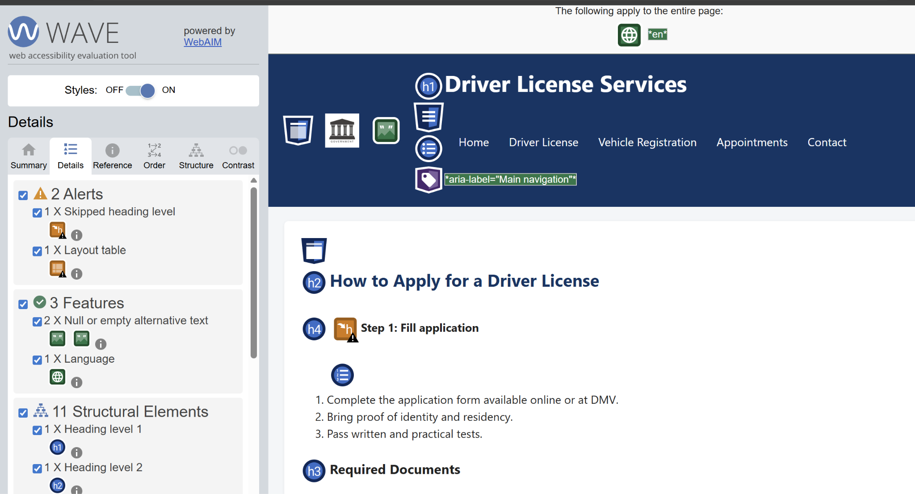

### Figure 2.2.4: Screenshot of WAVE result of license page

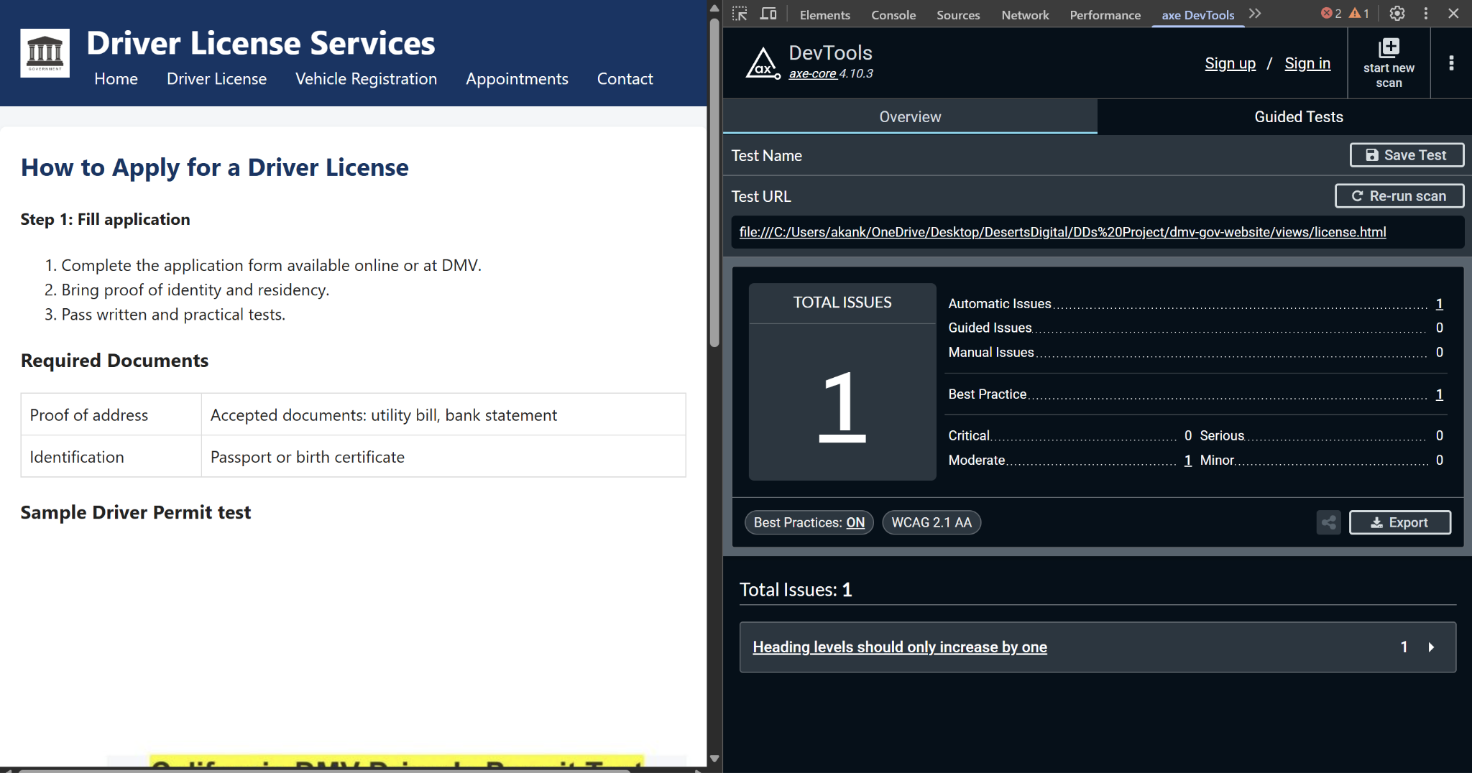

### Figure 2.2.5: Screenshot of AXE result of license page

### 

### Figure 2.2.6: Screenshot of Lighthouse result of license page

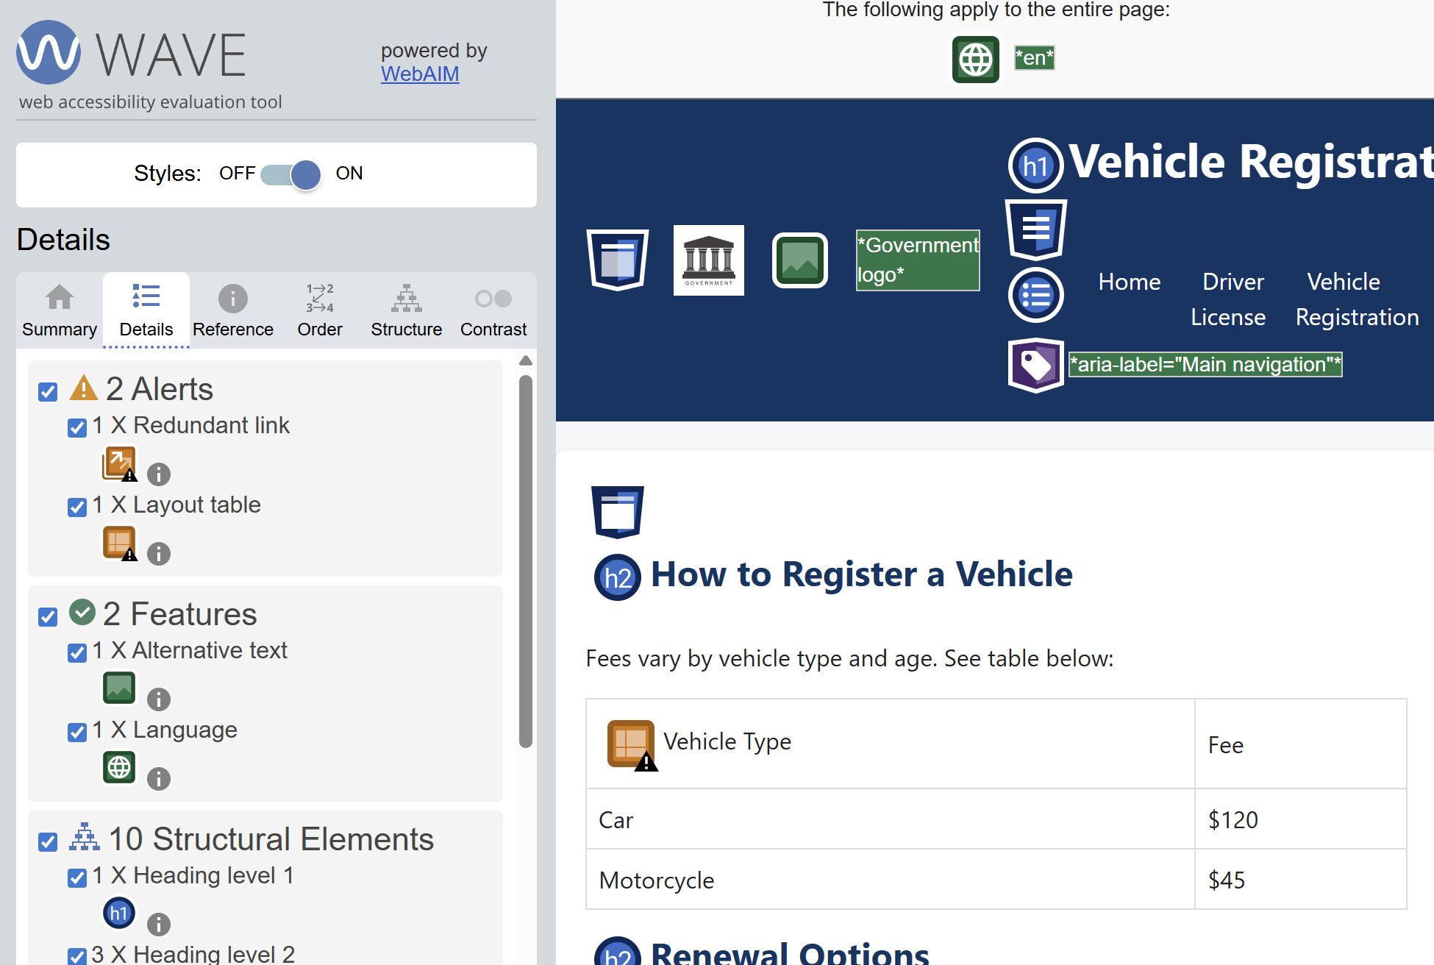

### Figure 2.2.7: Screenshot of WAVE result of registration page

### 

### Figure 2.2.8: Screenshot of AXE result of registration page

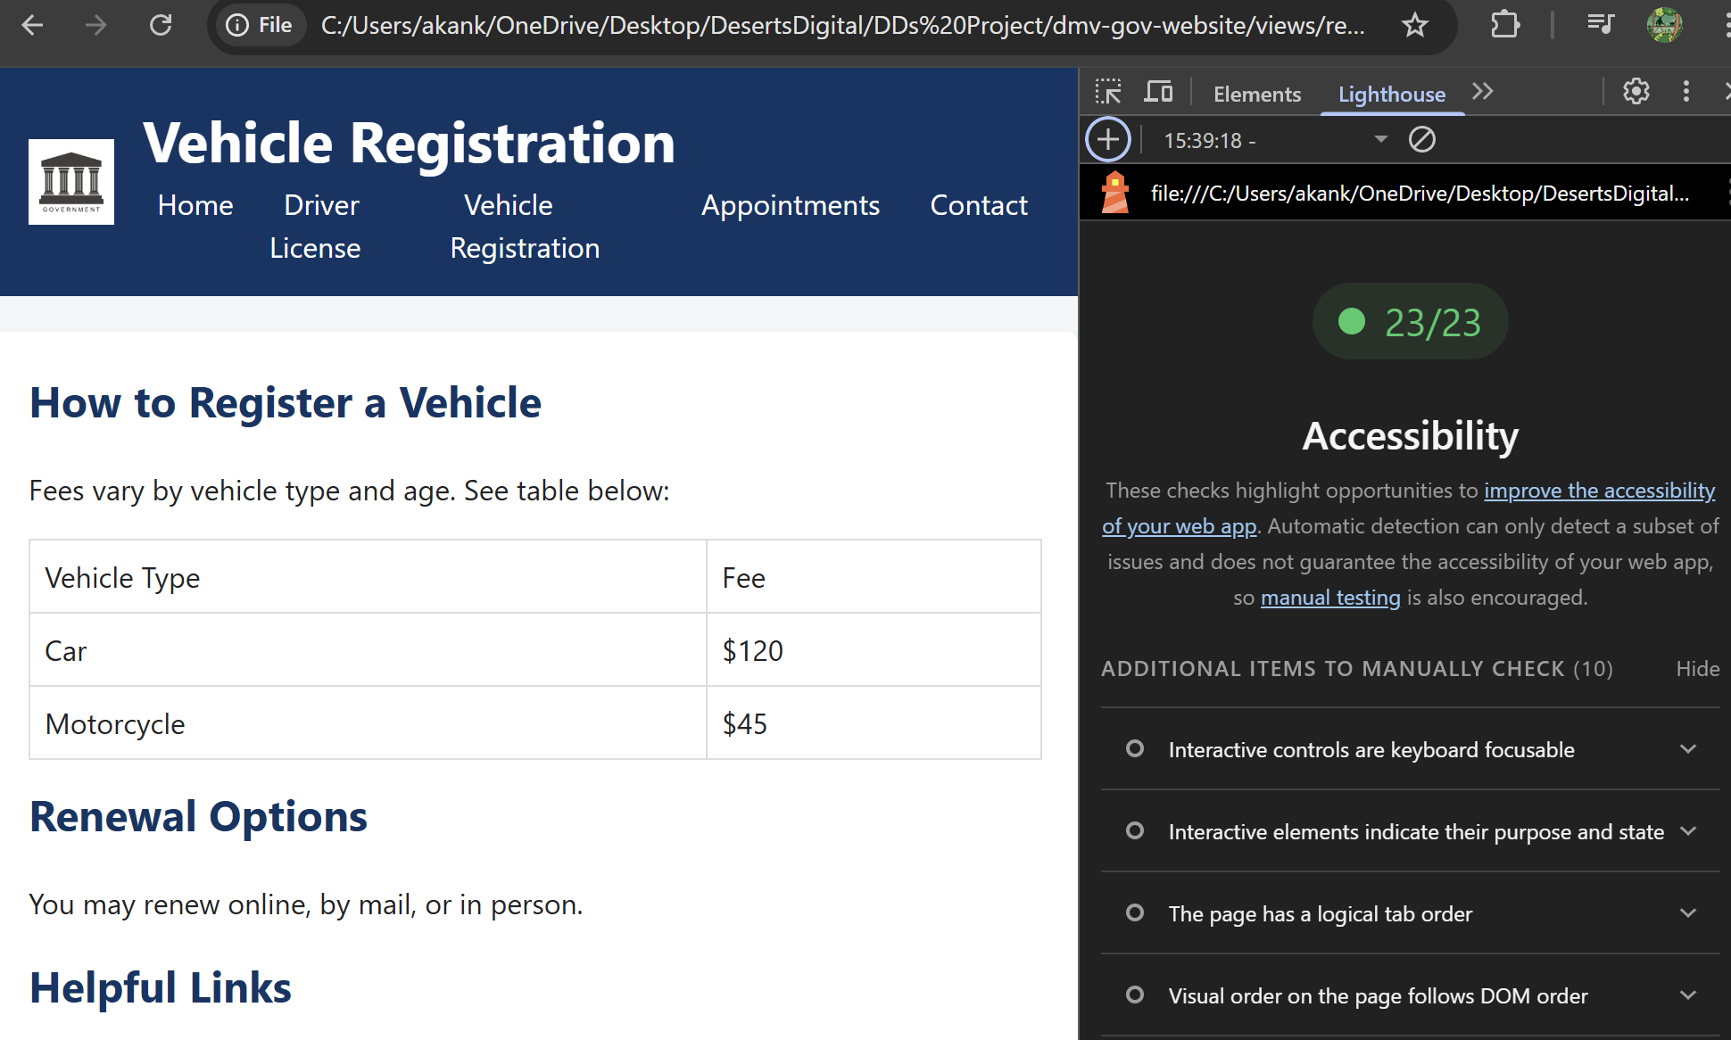

### Figure 2.2.9: Screenshot of Lighthouse result of registration page

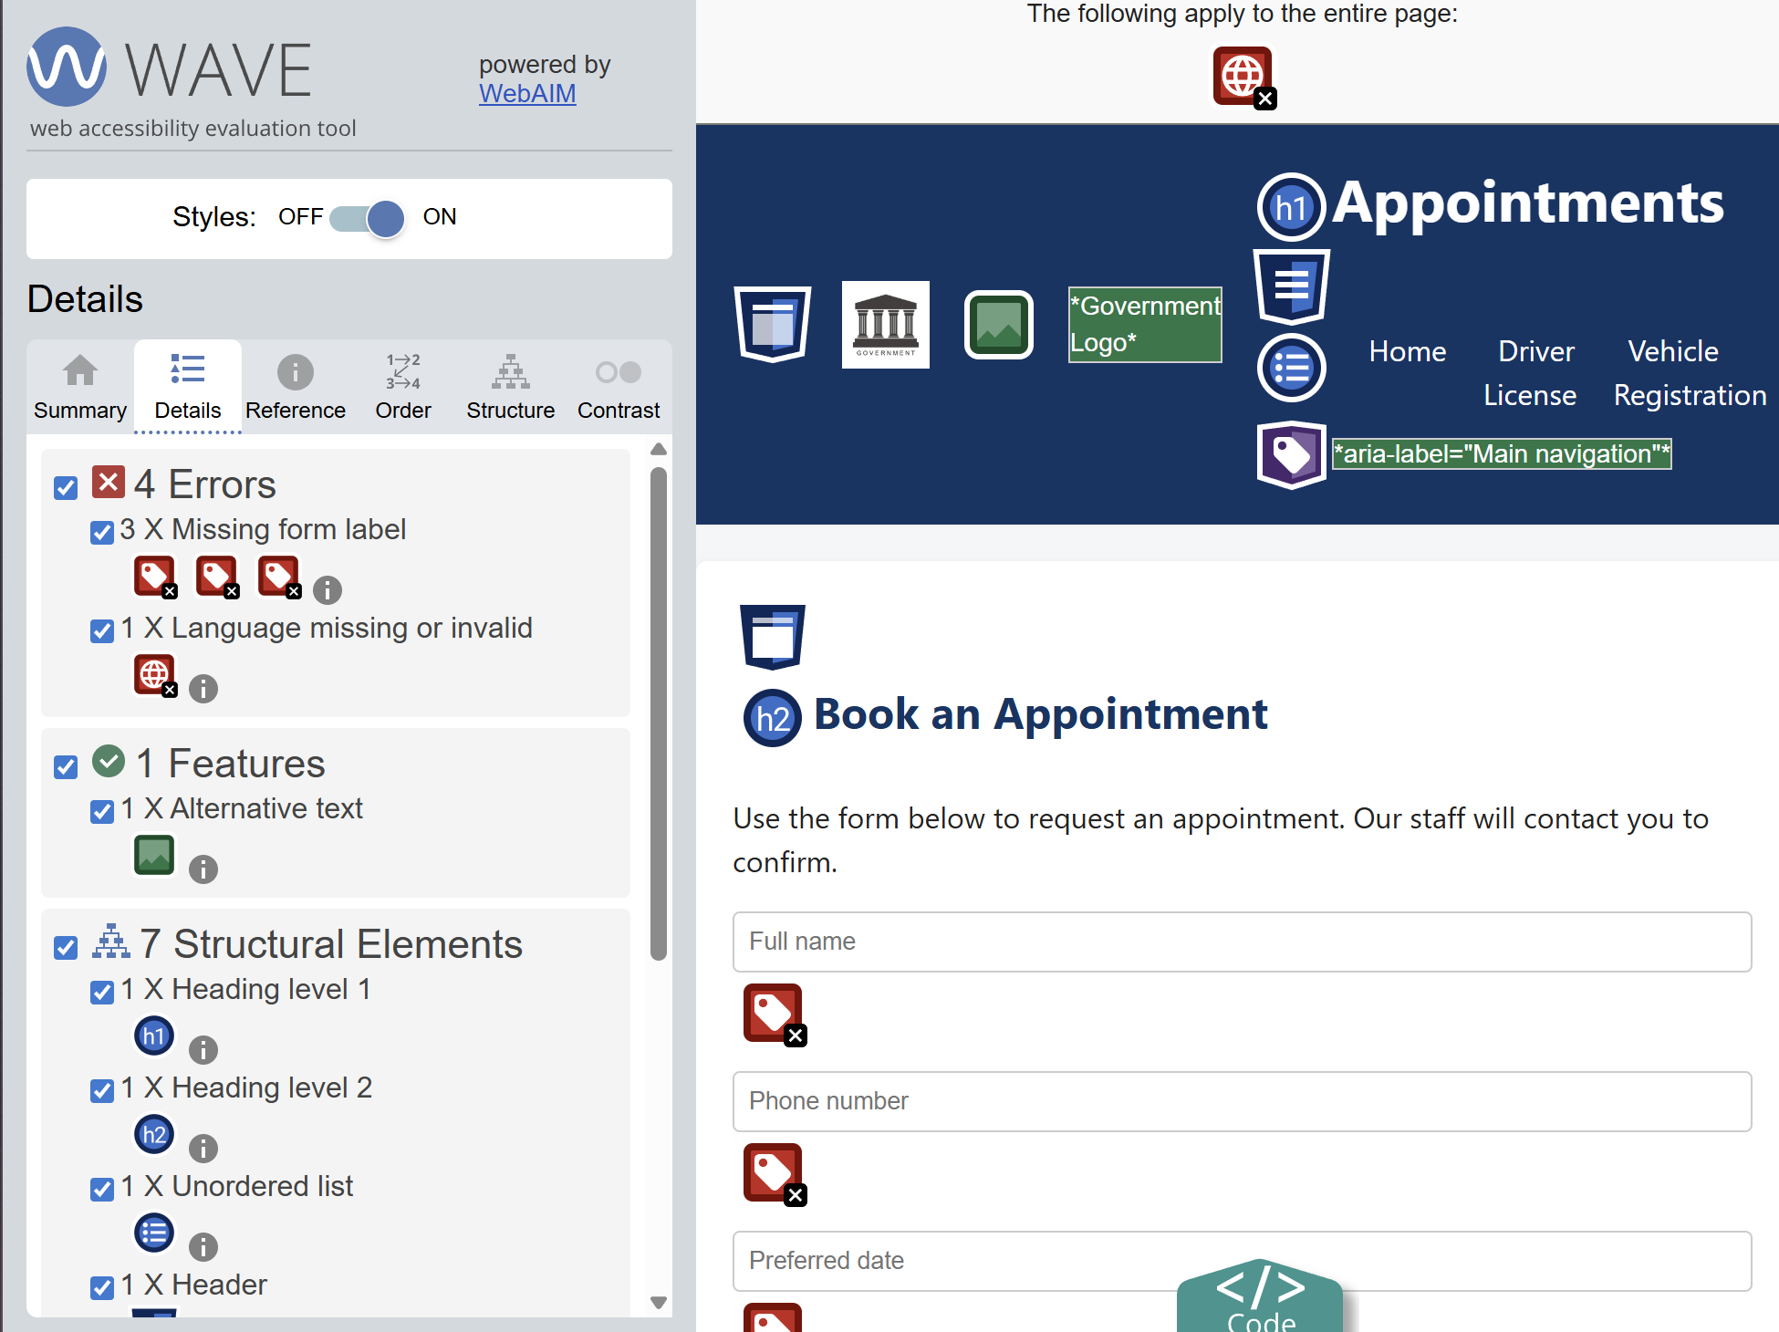

### Figure 2.2.10: Screenshot of WAVE result of appointment page

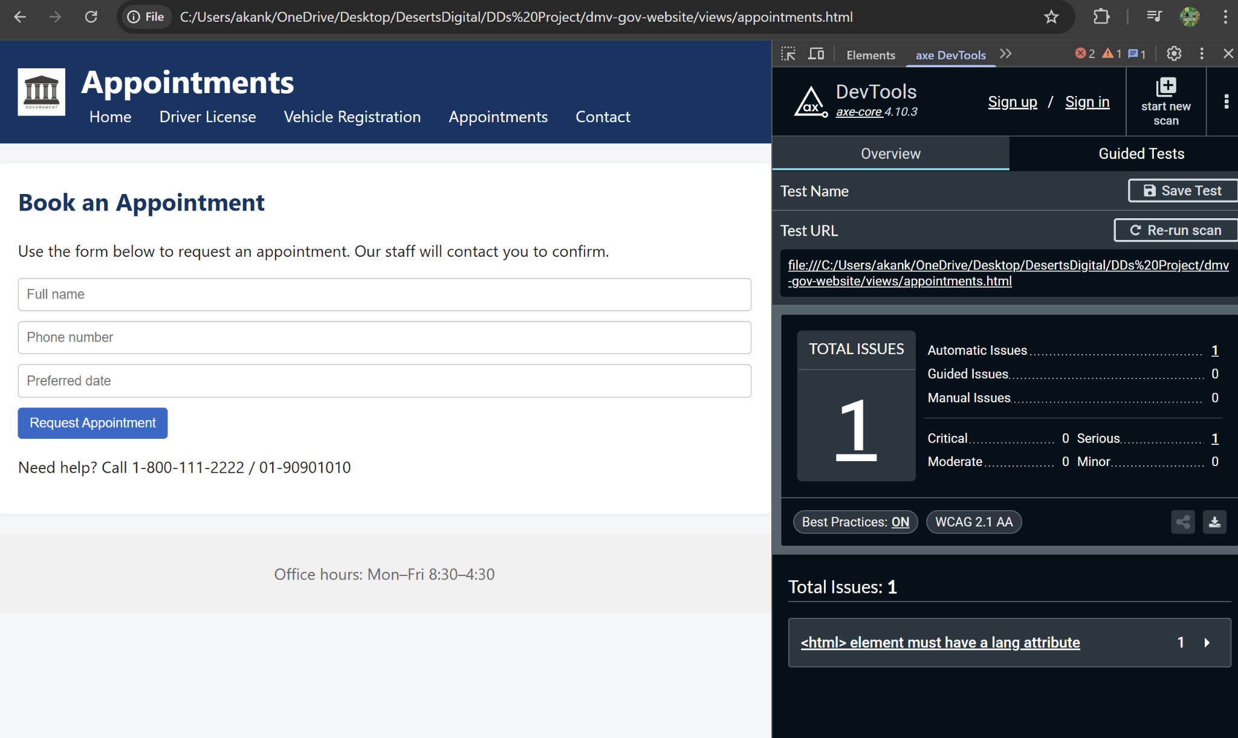

### Figure 2.2.11: Screenshot of AXE result of appointment page

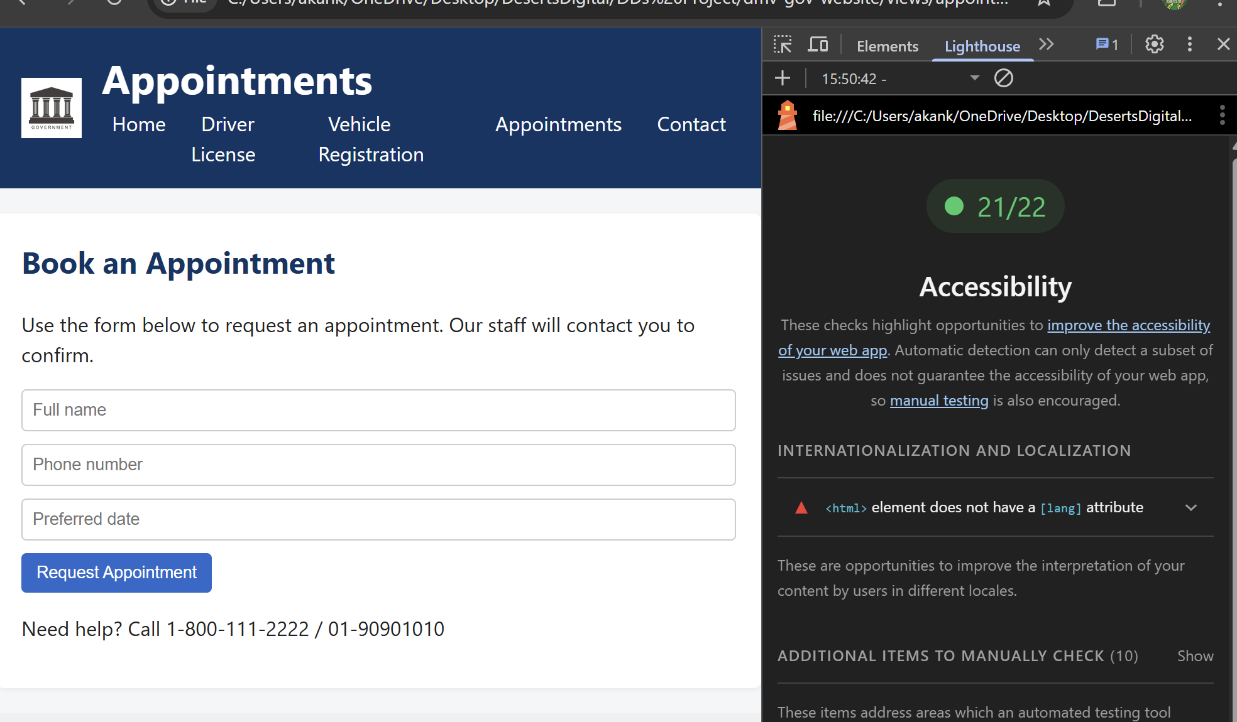

### Figure 2.2.12: Screenshot of Lighthouse result of appointment page

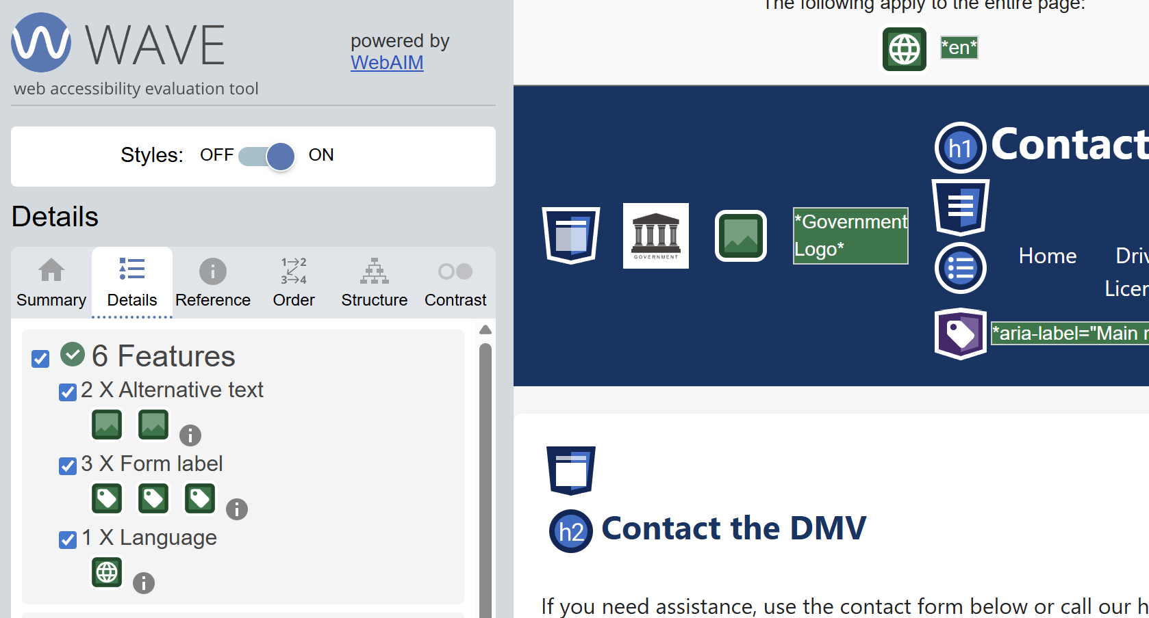

### Figure 2.2.13: Screenshot of WAVE result of contact page

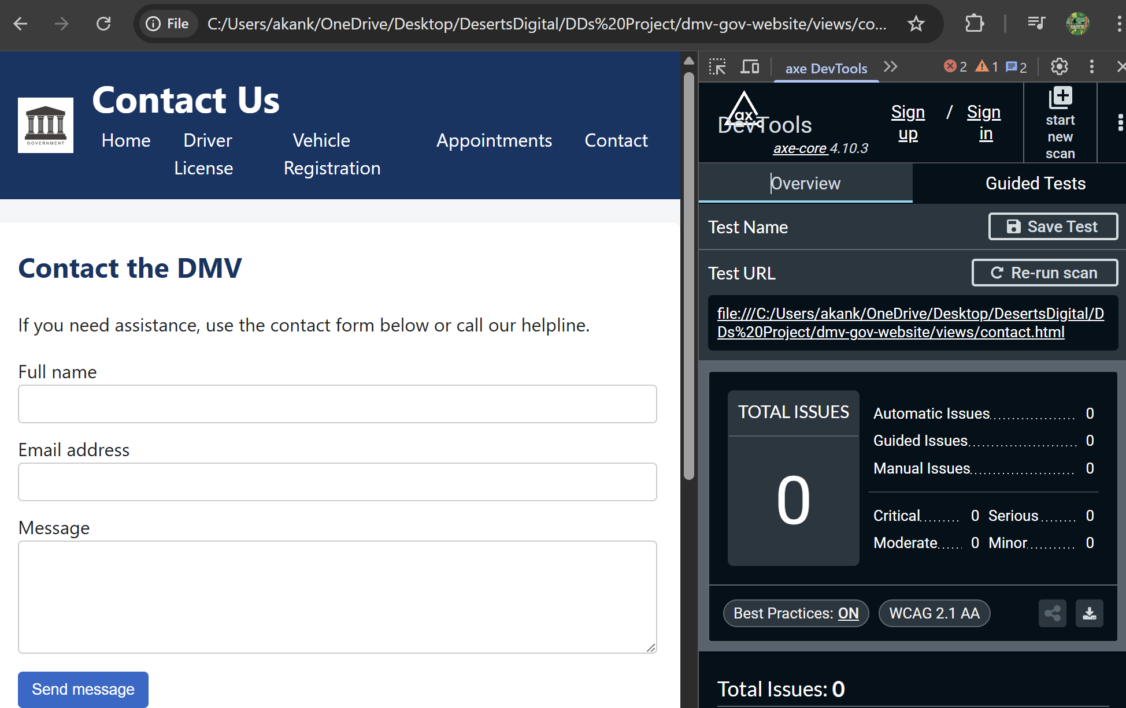

### Figure 2.2.14: Screenshot of AXE result of contact page

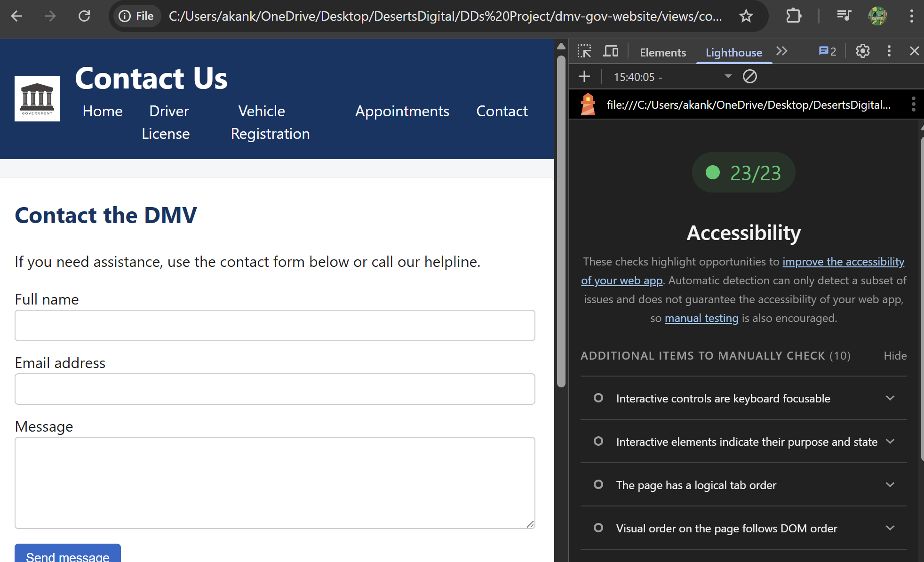

### Figure 2.2.15: Screenshot of Lighthouse result of contact page

### 

# Validation

## 3.1 Empty alt attribute

* Priority: High,
* Severity: High

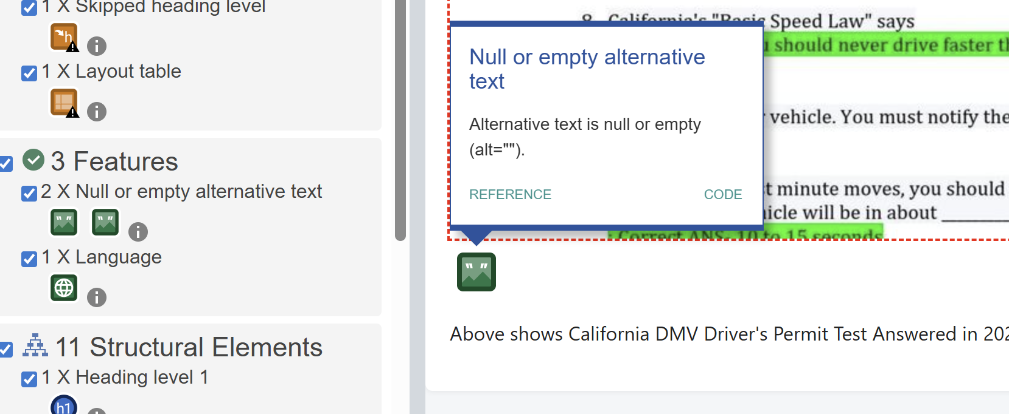

### Figure 3.1.1: Screenshot of empty alt attribute issue

## 3.2 Low contrast text

* Priority: Medium,
* Severity: Medium

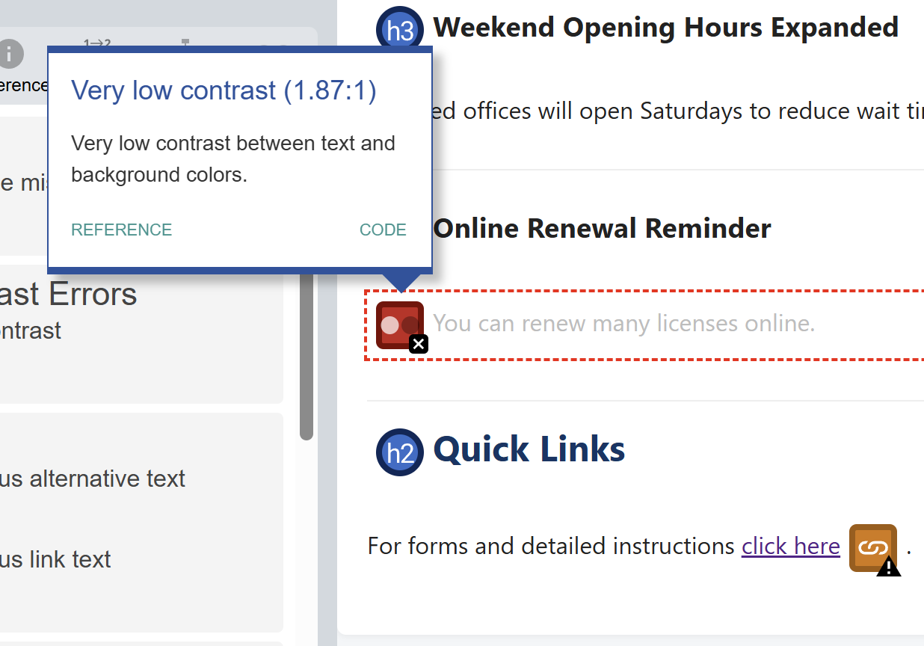

### Figure 3.1.2: Screenshot of low contrast text issue

## 3.3 Vague link text

* Priority: Medium,
* Severity: Medium

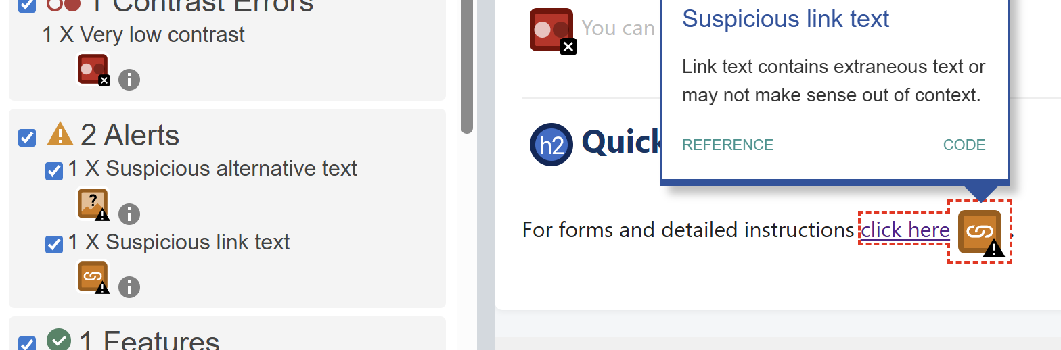

### Figure 3.1.3: Screenshot of vague link text issue

## 3.4 Missing lang attribute

* Priority: High,
* Severity: High

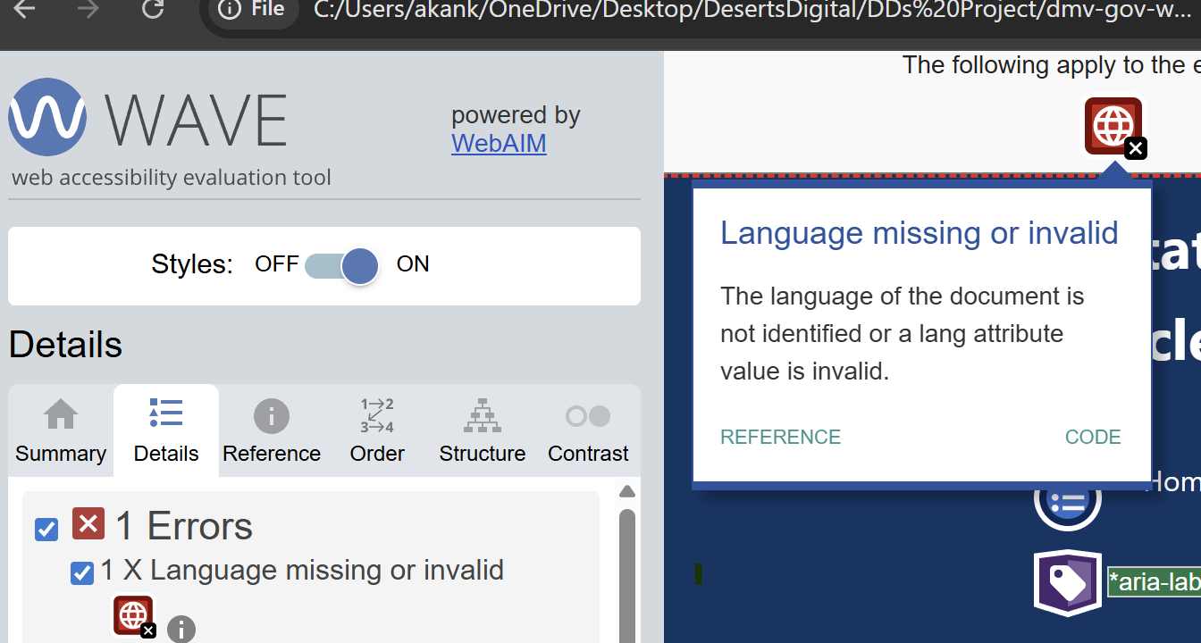

### Figure 3.1.4: Screenshot of missing lang attribute issue

## 3.5 Incorrect heading order

* Priority: Medium,
* Severity: Medium

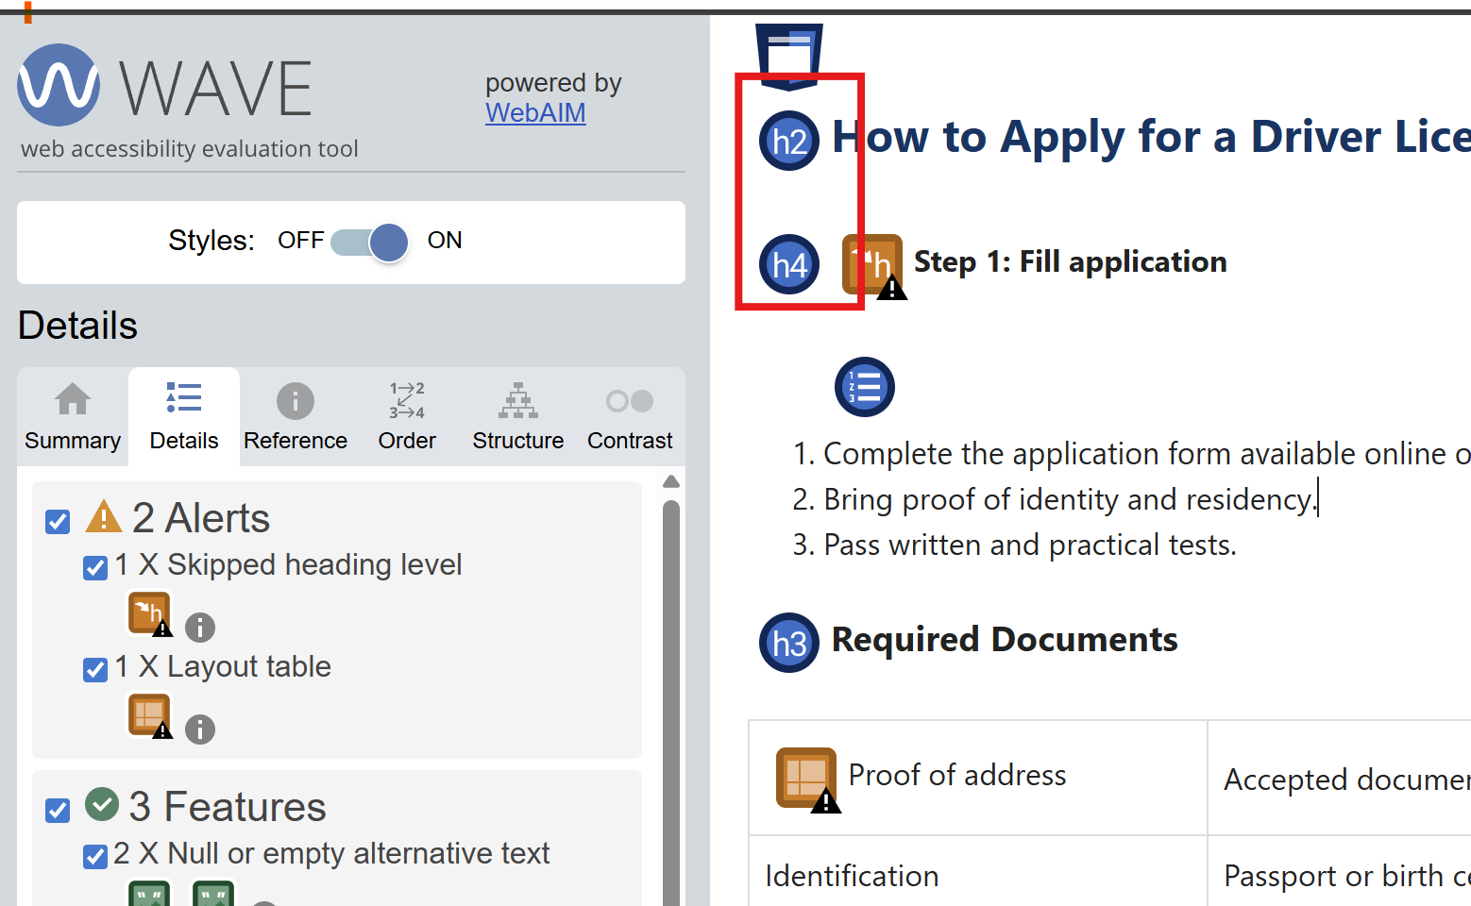

### Figure 3.1.5: Screenshot of incorrect heading order issue

## 3.6 Table missing <th> cells

* Priority: High,
* Severity: High

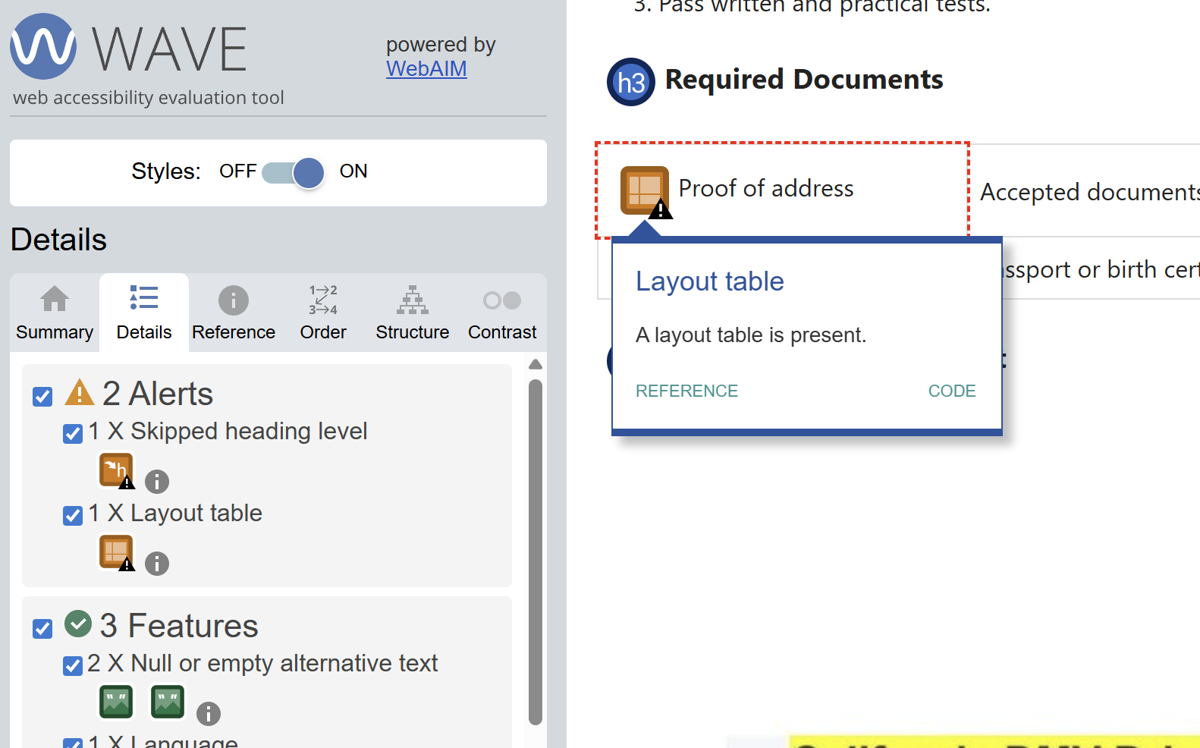

### Figure 3.1.6: Screenshot of missing table header attribute issue

## 3.7 Redundant links

* Priority: Low,
* Severity: Low

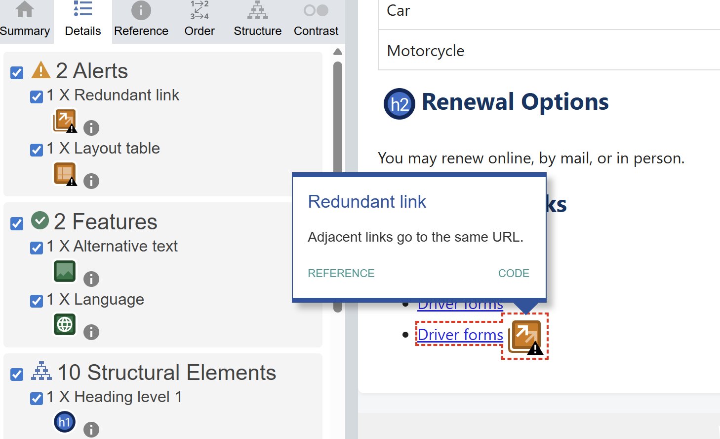

### Figure 3.1.7: Screenshot of redundant link issue

## 3.8 Missing <label> attribute

* Priority: High,
* Severity: High

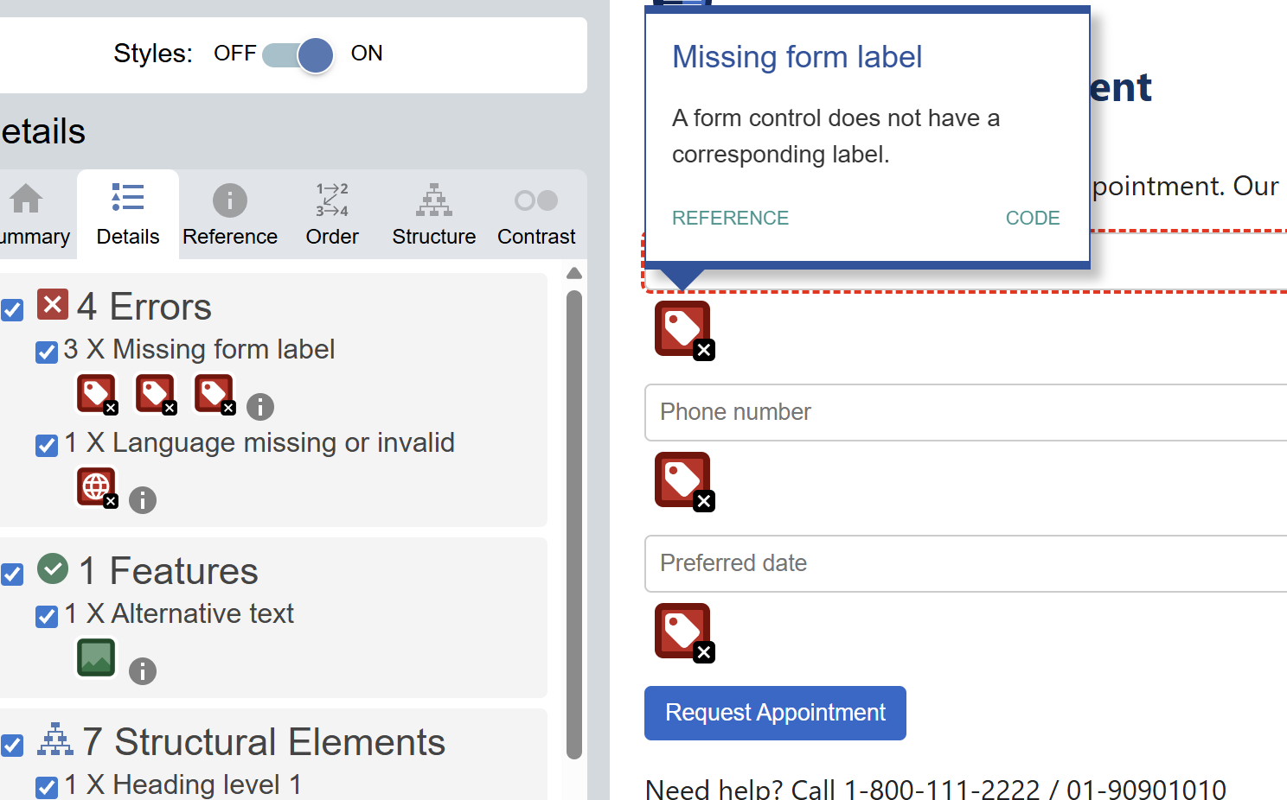

### Figure 3.1.8: Screenshot of missing <label> attribute issue

# Remediation

Following are the 5 issues with high priority and severity that was remediated:

## 4.1 Empty alt attribute

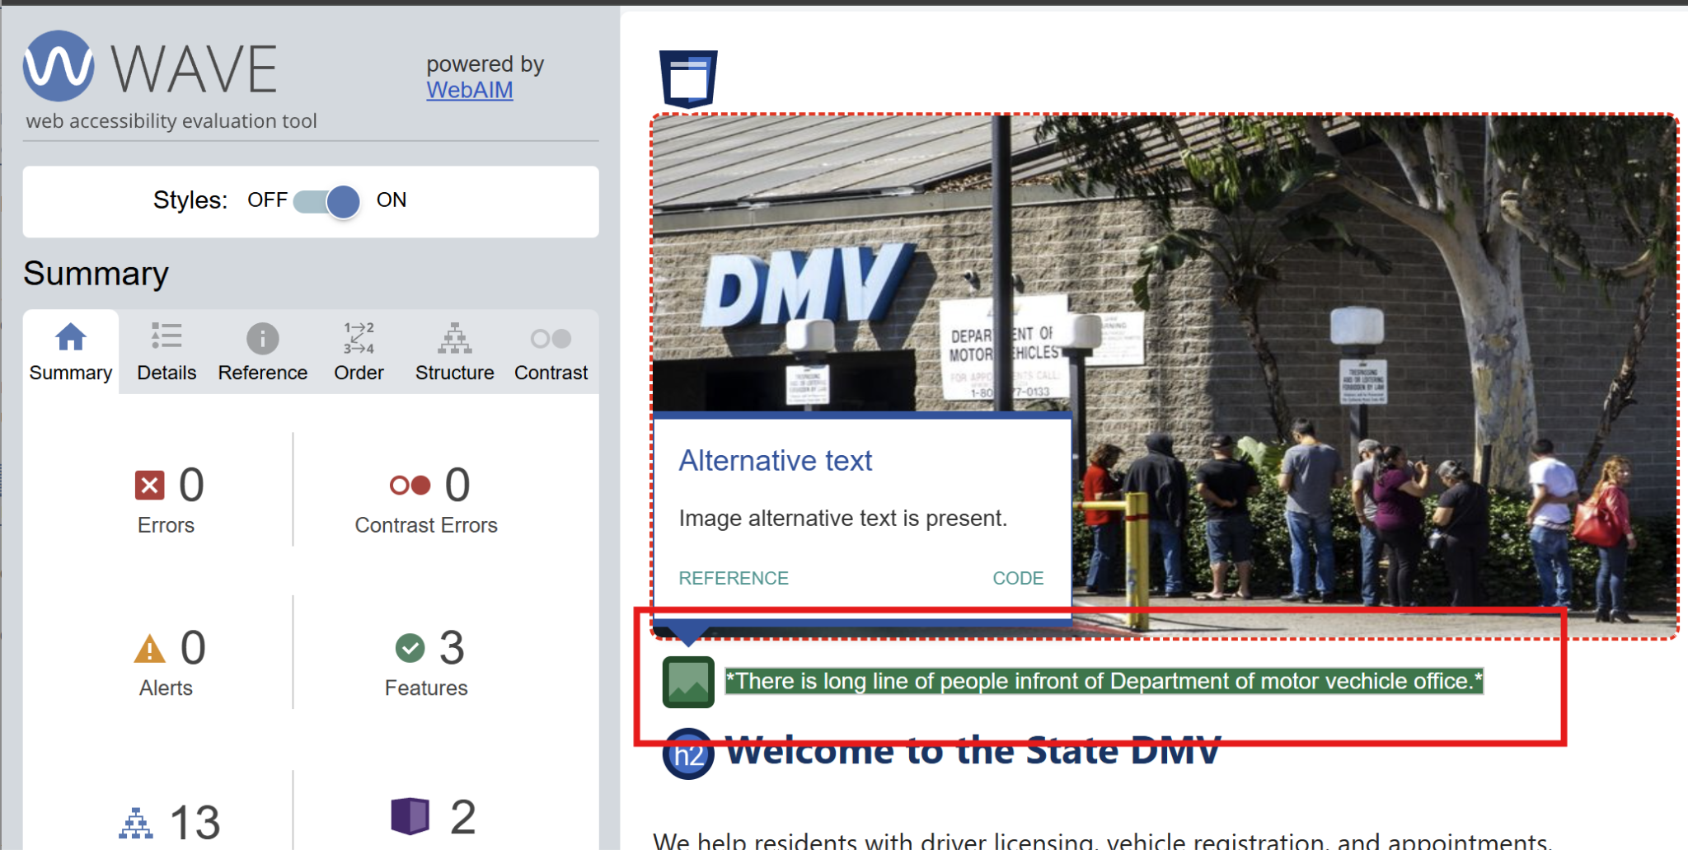

### Figure 4.1.1: Screenshot of fixed empty alt attribute issue

### [Link 4.1.2: Go to view fixed empty alt attribute validated by NVD](https://drive.google.com/file/d/1mGMXYJEcUeB2rkImZgzMQMAIqVFR2Amq/view?usp=drive_link)[A in video at drive](https://drive.google.com/file/d/18mtxXxmBQJ_9tsW2vBp2QFi6RagS8mQa/view?usp=drive_link)

## 4.2 Low contrast text

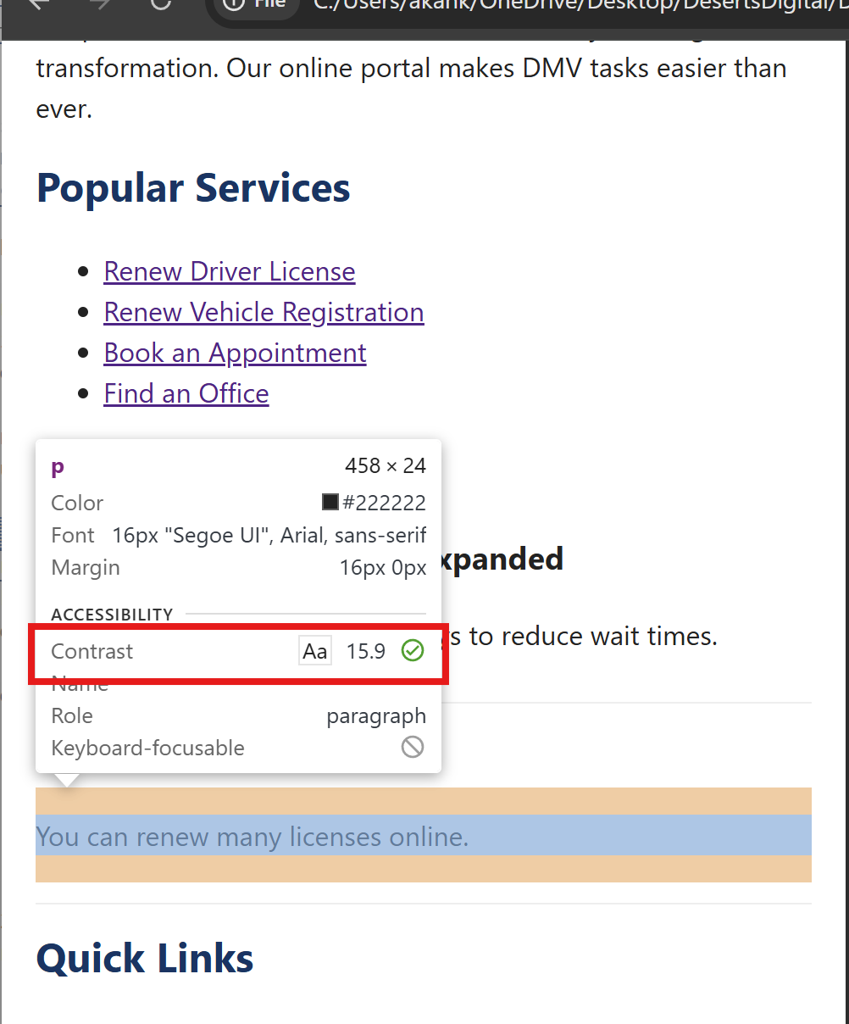

### Figure 4.2.1: Screenshot of fixed low contrast issue

## 4.3 Missing lang attribute

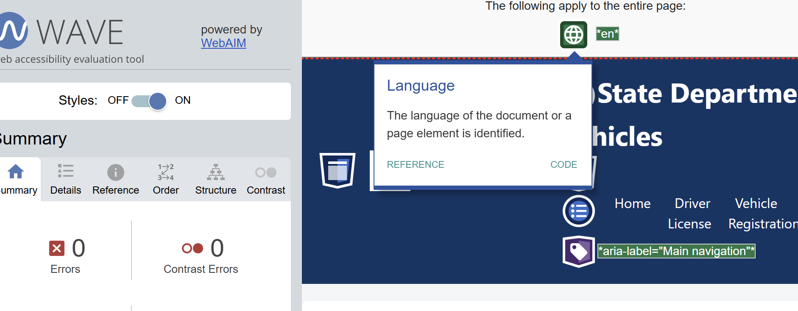

### Figure 4.3.1: Screenshot of fixed lang attribute issue

## 4.4 Table missing <th> cells

### [Link 4.4.1: Go to view fixed table header validated by NVDA in video at drive](https://drive.google.com/file/d/18mtxXxmBQJ_9tsW2vBp2QFi6RagS8mQa/view?usp=drive_link)

## 4.5 Missing <label> attribute

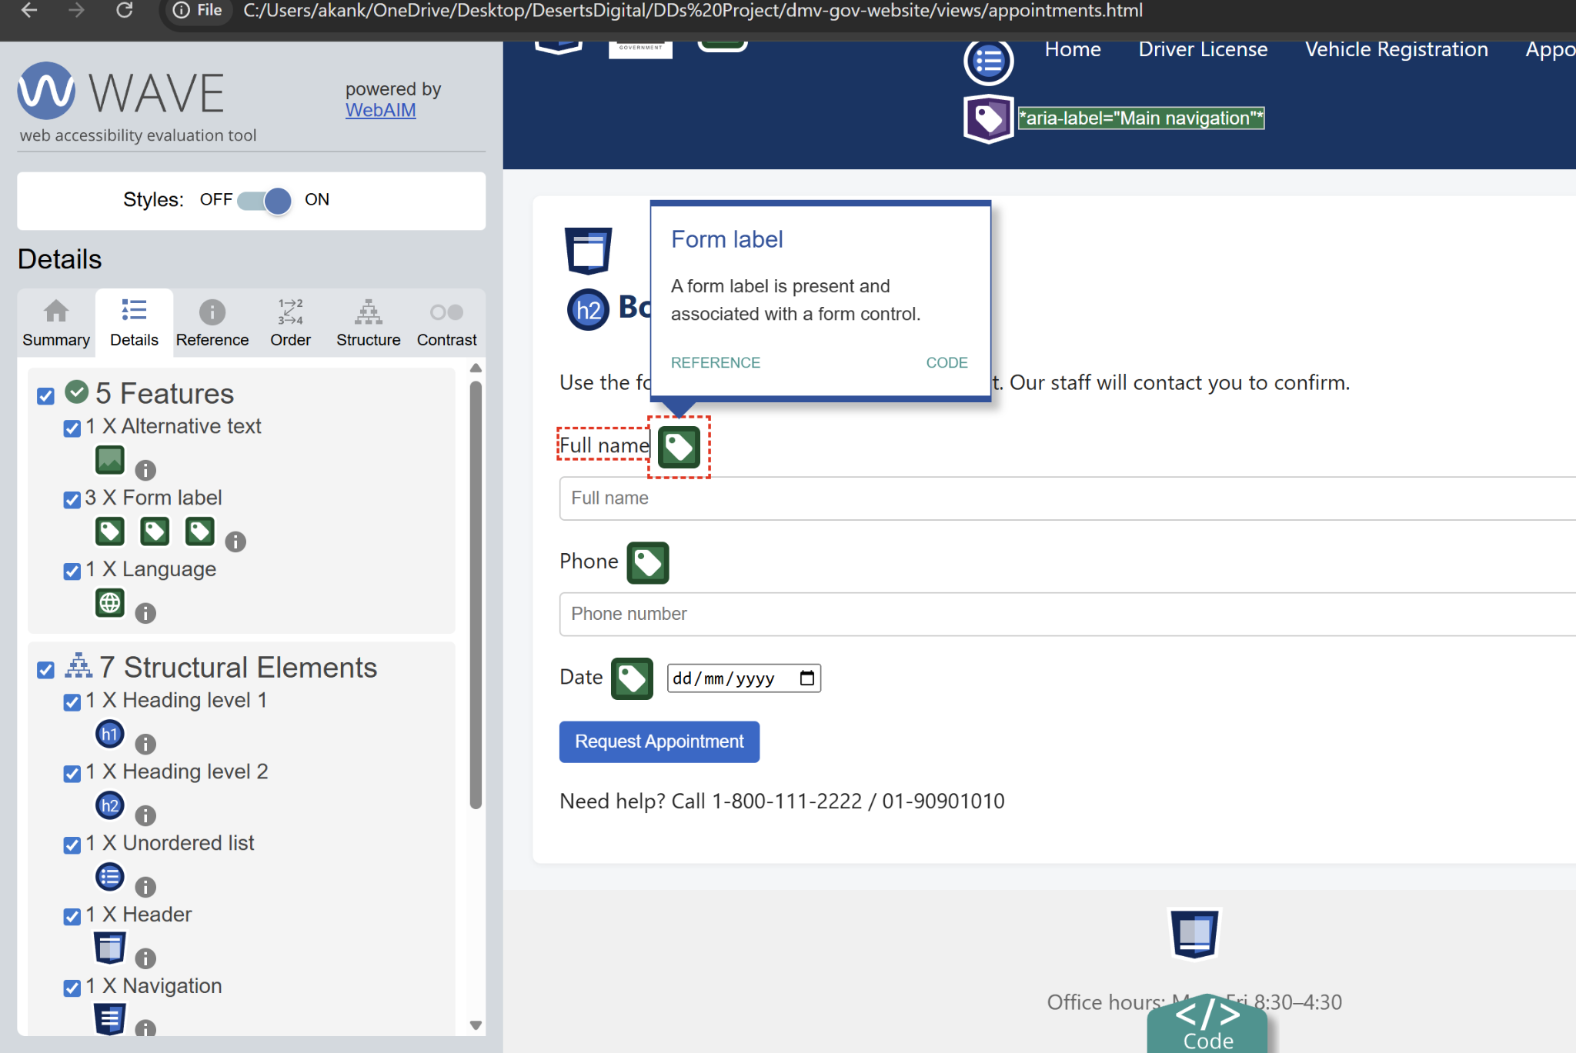

### Figure 4.5.1: Screenshot of fixed missing label attribute issue

# Client Report

# 

Project: Sample DMV Website ( [Go to github for code](https://github.com/ak-nksha/dmv-gov-website) )

Audit Date: 6 October, 2025

Remediation Date: 8 October,2025

Compliance Target: WCAG 2.1 level AA & Section 508

Tools Used: WAVE, AXE DevTools, Lighthouse, NVDA, Keyboard-only navigation

## 5.1 Audit Summary

The website was evaluated across five key pages: Home, License, Registration, Appointment, and Contact. Automated and manual testing revealed multiple accessibility violations, primarily affecting screen reader users, low-vision users, and keyboard-only navigation. The audit focused on semantic structure, visual contrast, labeling, and assistive technology compatibility.

## 5.2 Issues Identified

* **Empty alternative attribute**
  + WCAG: 1.3.1 Info and Relationships (A)
  + Priority: High
  + Severity: High
  + User Impact: Screen reader users cannot perceive the meaning of images, resulting in loss of critical information and context.
  + Value if fixed: Ensures all users, including blind and low-vision users, can understand visual content through descriptive alt text.
  + Risk if unfixed: Legal non-compliance, exclusion of users relying on screen readers, and failure to meet basic accessibility standards.
* **Low contrast text**
  + WCAG: 1.4.3 Contrast (Minimum) (AA)
  + Priority: Medium
  + Severity: Medium
  + User Impact: Text may be unreadable for users with low vision or color blindness, especially on mobile or in bright environments.
  + Value if fixed: Improves readability and usability for all users, especially those with visual impairments.
  + Risk if unfixed: Poor user experience, reduced legibility, and failure to meet Level AA compliance.
* **Vague link text** 
  + WCAG: 2.4.4 Link Purpose (In Context) (A)
  + Priority: Medium
  + Severity: Medium
  + User Impact: Users cannot predict where links lead; screen readers repeat generic phrases like “click here,” causing confusion.
  + Value if Fixed: Enhances navigation clarity and efficiency for all users, especially those using assistive technologies.
  + Risk if Unfixed: Frustration, disorientation, and reduced trust in site usability
* **Missing lang attribute** 
  + WCAG: 3.1.1 Language of Page (A)
  + Priority: High
  + Severity: High
  + User Impact: Screen readers may mispronounce content or use incorrect language settings, impairing comprehension.
  + Value if Fixed: Enables correct pronunciation and localization for multilingual users and screen readers.
  + Risk if Unfixed: Entire page may be misread, leading to confusion and non-compliance.
* **Incorrect heading order** 
  + WCAG: 2.4.6 Headings and Labels (AA)
  + Priority: Medium
  + Severity: Medium
  + User Impact: Users relying on keyboard or screen reader navigation may lose orientation and struggle to skim content.
  + Value if Fixed: Restores logical structure, improves navigation, and enhances user experience.
  + Risk if Unfixed: Disrupted navigation, user frustration, and failure to meet Level AA standards.
* **Table missing <th> cells** 
  + WCAG: 1.3.1 Info and Relationships (A)
  + Priority: High
  + Severity: High
  + User Impact: Screen readers cannot identify headers, making tabular data confusing or misleading.
  + Value if Fixed: Clarifies data relationships and improves comprehension for assistive tech users.
  + Risk if Unfixed: Misinterpretation of data, exclusion of users, and non-compliance.
* **Redundant links** 
  + WCAG: 2.4.4 Link Purpose (In Context) (A)
  + Priority: Low
  + Severity: Low
  + User Impact: Repetitive links clutter navigation and waste time for screen reader and keyboard users.
  + Value if Fixed: Streamlines navigation and reduces cognitive load.
  + Risk if Unfixed: Minor usability issues and inefficiency for assistive tech users.
* **Missing <label> attribute** 
  + WCAG: 3.3.2 Labels or Instructions (A)
  + Priority: High
  + Severity: High
  + User Impact: Form fields are inaccessible; users don’t know what information to enter.
  + Value if Fixed: Enables form completion for all users, including those using screen readers.
  + Risk if Unfixed: Blocks access to essential functions; fails legal and usability standards.

## 5.3 Remediation Actions

* **Empty alt attribute**
  + S**tatus:** Passed
  + Added descriptive alternative text to all images
  + Validated through Automated testing (WAVE) and Manual testing (NVDA)
* **Low contrast text**
  + S**tatus:** Passed
  + Adjusted foreground and background colors to meet contrast ratio
  + Validated through Chrome dev tool
* **Vague link text**
  + S**tatus:** Passed
  + Replaced ambiguous phrases like “Click here” with specific, descriptive link text
  + Not validated but remediated
* **Missing** lang **attribute**
  + S**tatus:** Passed
  + Added lang="en" to the <html> element for correct language identification
  + Validated through Automated testing (WAVE)
* **Incorrect heading order**
  + S**tatus:** Passed
  + Reordered headings sequentially (H1 → H2 → H3) to maintain logical structure
  + Not validated but remediated
* **Table missing** <th> **cells**
  + S**tatus:** Passed
  + Added <th> elements with proper scope to define table headers
  + Validated through Manual testing (NVDA)
* **Redundant links**
  + S**tatus:** Passed
  + Removed duplicate links to streamline navigation
  + Not validated but remediated
* **Missing** <label> **attribute**
  + S**tatus:** Passed
  + Added <label> elements linked to each form input using for and id
  + Validated through WAVE

## 5.4 Compliance Outcome:

Fixing these issues can ensure legal compliance, inclusive access, and professional credibility. Leaving them unfixed risks exclusion, lawsuits, and reputational damage.

Initial accessibility issues found: 8 across different pages

Final Status: Partially WCAG 2.1 AA Compliant

# 

# Presentation

# 

Presentation Link: [Go to ppt page drive](https://docs.google.com/presentation/d/18Rzb6zlrDY4G0xQQZ_67j2tTnuJYQzc6/edit?usp=drive_link&ouid=108789703326167908579&rtpof=true&sd=true)  / [Go to figma for presentation slides](https://www.figma.com/deck/SiJ3DMaOASWJUPqvM0eR2L/Untitled?node-id=2-451&t=G5meNLB1dGuVWiTH-1)

Recorded Presentation: [Go to recorded ppt video in drive](https://drive.google.com/file/d/1oc1oFGcg9K8kq3-A_tcPRenKJU8jWMSU/view?usp=drive_link)